PF ASSIGNMENT FINAL TERM



[ NAME:Linta Affaf]

[BSSE:1ST SEMESTER]

PF ASSIGNMENT FINAL TERM

QUESTION NO 1:

Write a program that take two strings from user find the length of these strings then concatenate these two strings and compare these strings. Convert first string into lower case and second string into upper case.

#include <iostream>

#include <string>

#include <algorithm>

using namespace std;

int main()

{

    string str1, str2;

    cout << "write the first string: ";

    cin >> str1;

    cout << "write the second string: ";

    cin >> str2;

    int length1 = str1.length();

    int length2 = str2.length();

    string concatenated = str1 + str2;

    transform(str1.begin(), str1.end(), str1.begin(), ::tolower);

    transform(str2.begin(), str2.end(), str2.begin(), ::toupper);

    int comparison = str1.compare(str2);

    cout << "the length of first string is " << length1 << endl;

    cout << "the length of second string is " << length2 << endl;

    cout << "the concatenated string is " << concatenated << endl;

    cout << "the first string in lowercase is " << str1 << endl;

    cout << "the second string in uppercase is " << str2 << endl;

    cout << "the result of comparison is " << comparison << endl;

    return 0;}

Output:

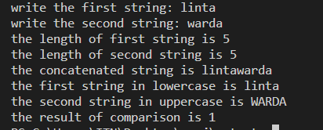

QUESTION NO 2:

1. Write a program that display the following output by using function.

@

@@

@@@

@@@@

@@@@@

#include <iostream>

using namespace std;

void displayPattern(int n)

{

    for (int i = 1; i <= n; i++)

    {

        for (int j = 1; j <= i; j++)

        {

            cout << "@";

        }

        cout << endl;

    }

}

int main()

{

    int rows = 5;

    displayPattern(rows);

    return 0;

}

Output:

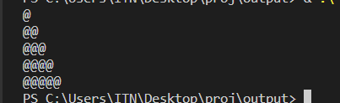

Question no 3:

Write a program that take two values from user and calculate sum by using recursion function.

#include <iostream>

using namespace std;

int calculatesum(int a, int b)

{

    if (b == 0)

    {

        return a;

    }

    else

    {

        return calculatesum(a + 1, b - 1);

    }

}

int main()

{

    int num1, num2;

    cout << "write the first integer: ";

    cin >> num1;

    cout << "write the second integer: ";

    cin >> num2;

    int sum = calculatesum(num1, num2);

    cout << "the sum of " << num1 << " "

         << "and"

         << " " << num2 << "is"

         << " " << sum << endl;

    return 0;

}

Output:

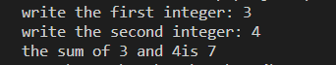

Question no 4:

Write a program that take any number from user and display the table of that number by using function passing pointer as a parameter.

#include<iostream>

using namespace std;

void displayTable(int\* numPtr){

    int num= \*numPtr;

    for(int i=1;i<=10;i++){

    cout<<num<<"x"<<i<<"="<<num\*i<<endl;

    }

}

int main(){

    int num;

    cout<<"enter a number: ";

    cin>>num;

    displayTable(&num);

    return 0;

}

Output:

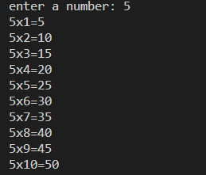

QUESTION NO 5:

Write a program that any 2 numbers and operator from user and perform arithmetic operation by using function.

#include <iostream>

using namespace std;

double performOperation(double num1, double num2, char op)

{

    double result;

    switch (op)

    {

    case '+':

        result = num1 + num2;

        break;

    case '-':

        result = num1 - num2;

        break;

    case '\*':

        result = num1 \* num2;

        break;

    case '/':

        result = num1 / num2;

        break;

    default:

        cout << "invalid operator!" << endl;

        return 0;

    }

    return result;

}

int main()

{

    double num1;

    double num2;

    char op;

    cout << "enter num1: ";

    cin >> num1;

    cout << "enter num2: ";

    cin >> num2;

    cout << "enter operator: ";

    cin >> op;

    double result = performOperation(num1, num2, op);

    cout << "the result of " << num1 << " " << op << " " << num2 << "is " << result << endl;

    return 0;

}

Output:

